**[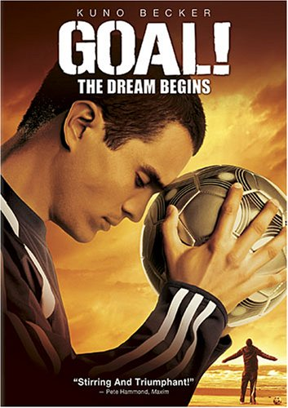](https://lh3.googleusercontent.com/-Li61ehdJulo/YQPS4PBUDjI/AAAAAAAARMg/nkovp-eqT9Yd2xOi4-qjE8CKqp1-lpmwQCLcBGAsYHQ/image.png)**

Santiago, a young Mexican American, fulfills his dream of playing soccer when a chance encounter in inner-city Los Angeles results in a trip to England to try out for the Newcastle United soccer team.

In the opening scenes of this film, Santiago Munez (Leonardo Guerra) as a young boy is sneaking across the Mexican border into the United States when he almost leaves behind his much used and beloved soccer ball. Ten years later, Santiago (Kuno Becker) is living in a run-down section of Los Angeles with his father Herman (Tony Plana), his grandmother (Miriam Colon), and his younger brother. Santiago works in the kitchen of a Chinese restaurant and helps his dad who runs a gardening business. But his real passion is playing amateur soccer.

One day Glen Foy (Stephen Dillane), a part-time talent scout from England, sees him on the field and is impressed enough to make a call to Erik Dornhelm (Marcel Iures), the manager of the Newcastle United team in England. However, when his father takes the money he has saved, Santiago has no way of getting to the tryout. Luckily, his grandmother sees that he needs to take his shot at the dream of playing professional soccer for a living. She gives him her blessing and the money he needs to travel overseas.

Once in England, he faces one challenge after another trying to make the team. Glen turns out to be a loyal and enthusiastic supporter of this talented young man who, after a setback, manages to win a slot as a trainee. Santiago falls in love with Roz (Anna Friel), a nurse who sees that he is different from other men with his single-minded focus on his dream. He is also taken under the wings of Gavin Harris (Alessandro Nivola), a superstar soccer player who introduces him to the fast lane of fame and fortune with all its attendant problems. The manager of Newcastle United goes out of his way to give Santiago the time he needs to learn the ways of English soccer.

*Goal! The Dream Begins* is directed by Danny Cannon and proves to be a pleasant drama revolving around the popular sport of soccer. The film explores the power of Santiago's yearning and the things he learns on the path to fulfilling his dream. The story's moral message, which some movie critics will no doubt dismiss as being too melodramatic and predictable, is that we can't do become the best we are meant to be without the love and enthusiasm of others. We think this is a point worth making in a time when the myth of individualism still holds sway. Robert Muller has stated: "Have a dream and believe in it. Strong dreams always come true." Especially with a little help from people enthusiastically cheering us on from the sidelines